BackTestBench: modular backtesting and sandbox platform for trading

Product vision:
BackTestBench is a strategy research platform focused on the Russian financial market. It enables traders to test, compare, and analyze trading strategies on historical data and in realistic sandbox simulations. The platform combines backtesting, analytics, and testing strategies in real time into a single environment, helping traders make data-driven decisions with bigger confidence.

Target audience:
Traders, financial telegram bot owners

User stories:
- As a user, I want to find out how well the best strategy is performing at the current time;
- As a strategy creator, I want to be able to create my own strategy and test it;
- As a user, I want the service to issue only those strategies that can pay off the interest on the bank deposit in a year.

MVP 1 scope:
- one strategy
- working backtest engine, trade log generation
- computing minimal metrics from TradeLog (P&L)
- implement broker integration (any broker)
- simple frontend (show analytics and strategy description)

Functional requirements:
- download historical market data from an external source via a single adapter;
- store and reuse uploaded data without requesting it unnecessarily.;
- allow you to create/modify trading strategies in the form of plug-ins/settings with customizable parameters with GUI;
- run a strategy backtest on a selected historical interval;
- simulate transactions and a virtual portfolio in backtesting loop;
- calculate strategy performance metrics (P&L, max drawdown…);
- save the results of runs and metrics in database;
- compare multiple strategies and scenarios for different actives (oil, gold, dollar);
- create a rating of the best strategies;
- validating strategies in real-time via trading bot, which interact with API that allows to SELL, HOLD, BUY and return portfolio (no real money)
- send notifications about failures and the status of recalculations;
- provide an interface for viewing results and downloading strategy configurations

Non-functional requirements (most essential):
- Modularity/extensibility:
- system must be modular;
  - adding new strategies should not lead to rewriting module core;
  - the architecture should support the expansion of the list of metrics and analytical modules;
  - different modules (backtesting, strategy, etc.) must be separated in code;
- Reliability:
- failure of one module should not lead to user deception (showing to user outdated or non-working strategies)
- if it is not possible to validate strategies in the sandbox, service must notify; the user;
- the data and results of the runs must be reproducible;
- 90% availability;
- Data integrity:
- historical data must be validated before use;
- the database must maintain the integrity of the trade log and metrics;
- Reproducibility:
- the same set of input data and configuration should lead to the same result;
- the strategy version and configuration must be saved along with the result;
- Functional Suitability:
- basic modules (Backtesting engine, trading bots, adapter, strategy module and analytics module) should be implemented;
- the user should really get the best strategy from the ones presented and created by him;
- Performance:
- determining the best strategy in the backtesting cycle should be done at least once every two weeks but not two weeks;

Static view:
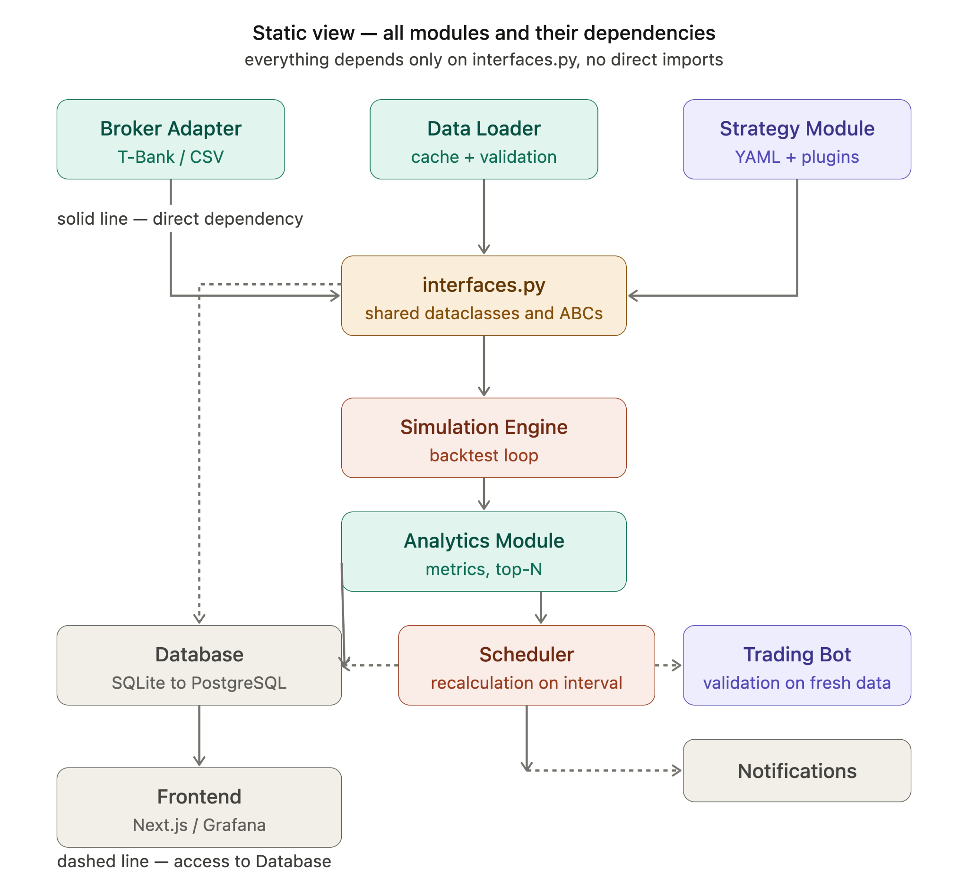
Database - the central storage used by almost all modules. Stores: historical candles, strategy configurations, backtest results (trade logs), calculated metrics, the current top-N strategy list, and failure logs. MVP 1 may use SQLite as the database; later MVP versions will use PostgreSQL.
Broker Adapter - the single entry point for any broker-related data. Wraps the T-Bank API, another broker, or a CSV file into a unified interface with three methods: get_candles(), place_order(), get_portfolio(). It is used by two modules - Data Loader (for historical data) and Trading Bot (for real-time order execution). The idea is that when changing brokers, only the adapter changes while the rest of the system remains untouched.
Data Loader - responsible for ensuring that historical data is available in the system. Requests candles through the Broker Adapter using get_candles(instrument, from_dt, to_dt, timeframe), where from_dt and to_dt define an explicit date range. Before making a request, it checks the cache in the database: the broker is queried only for data ranges that are not yet present in the database. Validates data (removes gaps, duplicates, and invalid values), normalizes it into a unified format, and stores it. Provides data to the Simulation Engine as List[Candle].
The requested date range depends on the context: for backtesting, it is a user-defined historical period; for updates before Scheduler recalculation, it is the period from the last synchronization until now.
Strategy Module - a module for describing, storing, and managing trading strategies. Each strategy is implemented as an independent plugin inheriting from the common BaseStrategy interface and can be configured through a YAML configuration containing parameters (indicator settings, entry and exit thresholds, time filters, risk management parameters, etc.). The module maintains a registry of available strategies and creates an instance of the selected strategy based on its configuration. All strategies implement a unified method on_candle(candle, portfolio) -> Signal, allowing the Simulation Engine to work with any strategy in the same way without knowing the details of its internal implementation. Strategy configurations are stored in the database, and new strategies can be added to the system by creating a new plugin without modifying the platform core.
Simulation Engine - the core of the backtesting system. Receives List[Candle] from the Data Loader and a strategy instance from the Strategy Module. Processes candles one by one, calling on_candle() for each candle, receiving a signal (BUY / SELL / HOLD), simulating order execution, and maintaining the state of a virtual portfolio. At the end, it produces a complete Trade Log - a list of all trades with entry/exit prices, volume, and P&L for each trade. This log is passed to the Analytics Module and stored in PostgreSQL. No broker communication is performed.
Analytics Module - calculates metrics based on the Trade Log. Outputs: total P&L, Sharpe ratio, max drawdown, win rate, and comparison with a baseline bank deposit return (13% annual yield). Results are written to PostgreSQL in the metrics table. The module also creates and updates the top-N list - a ranked list of strategies sorted by P&L, which is used by the Trading Bot to determine which strategies should be executed. The same data is read by the Frontend for dashboard visualization.
Scheduler - launches periodic recalculations. Every N days (configurable, default: 2 weeks), instructs the Data Loader to fetch fresh data from the last synchronization until recent time (while leaving part of the freshest data reserved for the Trading Bot), then runs all known strategies through the Simulation Engine and Analytics Module, updating the top-N list in PostgreSQL. If something goes wrong (API unavailable, backtest failure), it leaves the current top-N list unchanged and sends an alert through Notifications. Implemented as a separate container using APScheduler or cron.
Trading Bot - a module for additional validation of the best-performing strategies on Sandbox API. After the main backtest is completed, the module retrieves the top-N strategy list from the database and launches a separate simulation process for each strategy. Unlike the main backtest, which uses historical data up to a specific date, the Trading Bot executes strategies on Sandbox APIs, which allow it to perform actions and get outcomes, so that we can check strategy in real time. For each new candle, the module invokes on_candle() of the corresponding strategy, simulates trades, and collects validation results. The resulting metrics are stored in the database and are used to confirm or revise strategy rankings before further use.
Notifications - a simple module triggered by the Scheduler in case of failures. Sends emails via SMTP. It can also send a daily digest containing current bot P&L, status of the latest recalculation, and information about generated alerts.
Frontend - reads data from PostgreSQL through a FastAPI backend. Displays: strategy list with metrics, historical entry/exit charts, comparison of multiple backtests, current top-N ranking, and bot statuses. Allows uploading a YAML configuration for a new strategy and launching a backtest. Next.js will be used; if development falls behind schedule, Grafana will be used as a quick fallback directly on top of PostgreSQL. Also allows the creation and save of new strategies configured by users.

Dynamic view: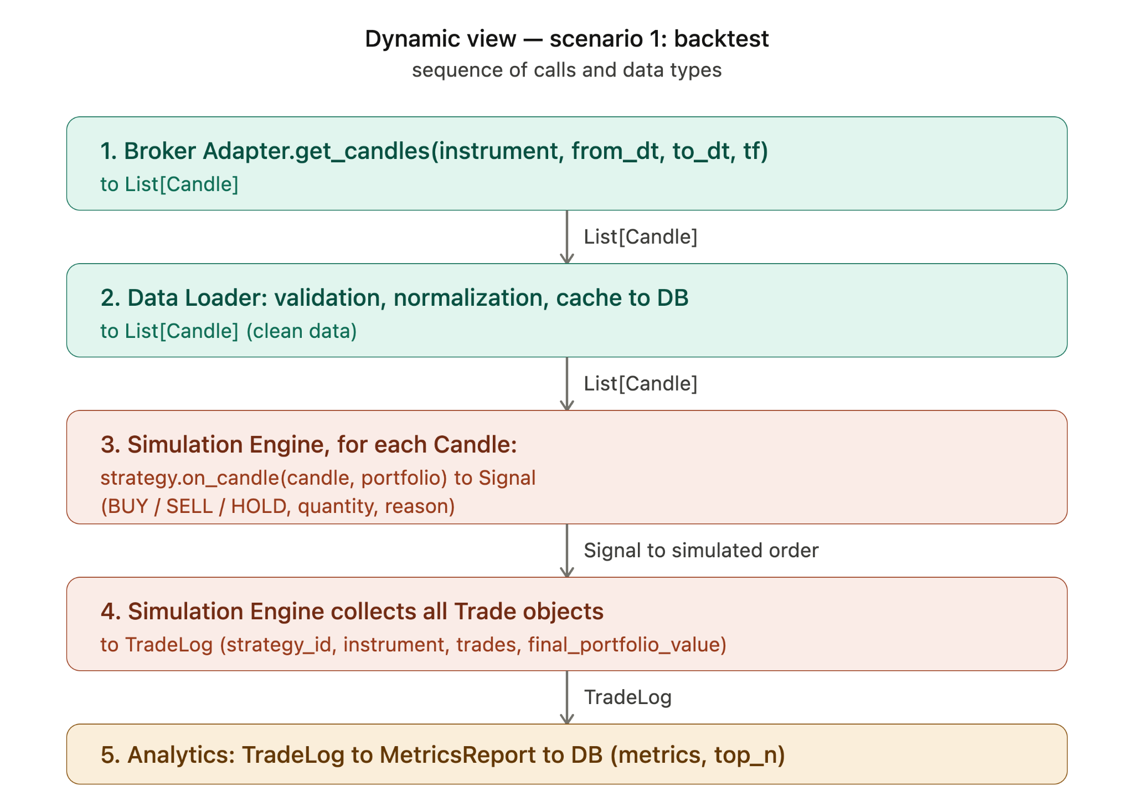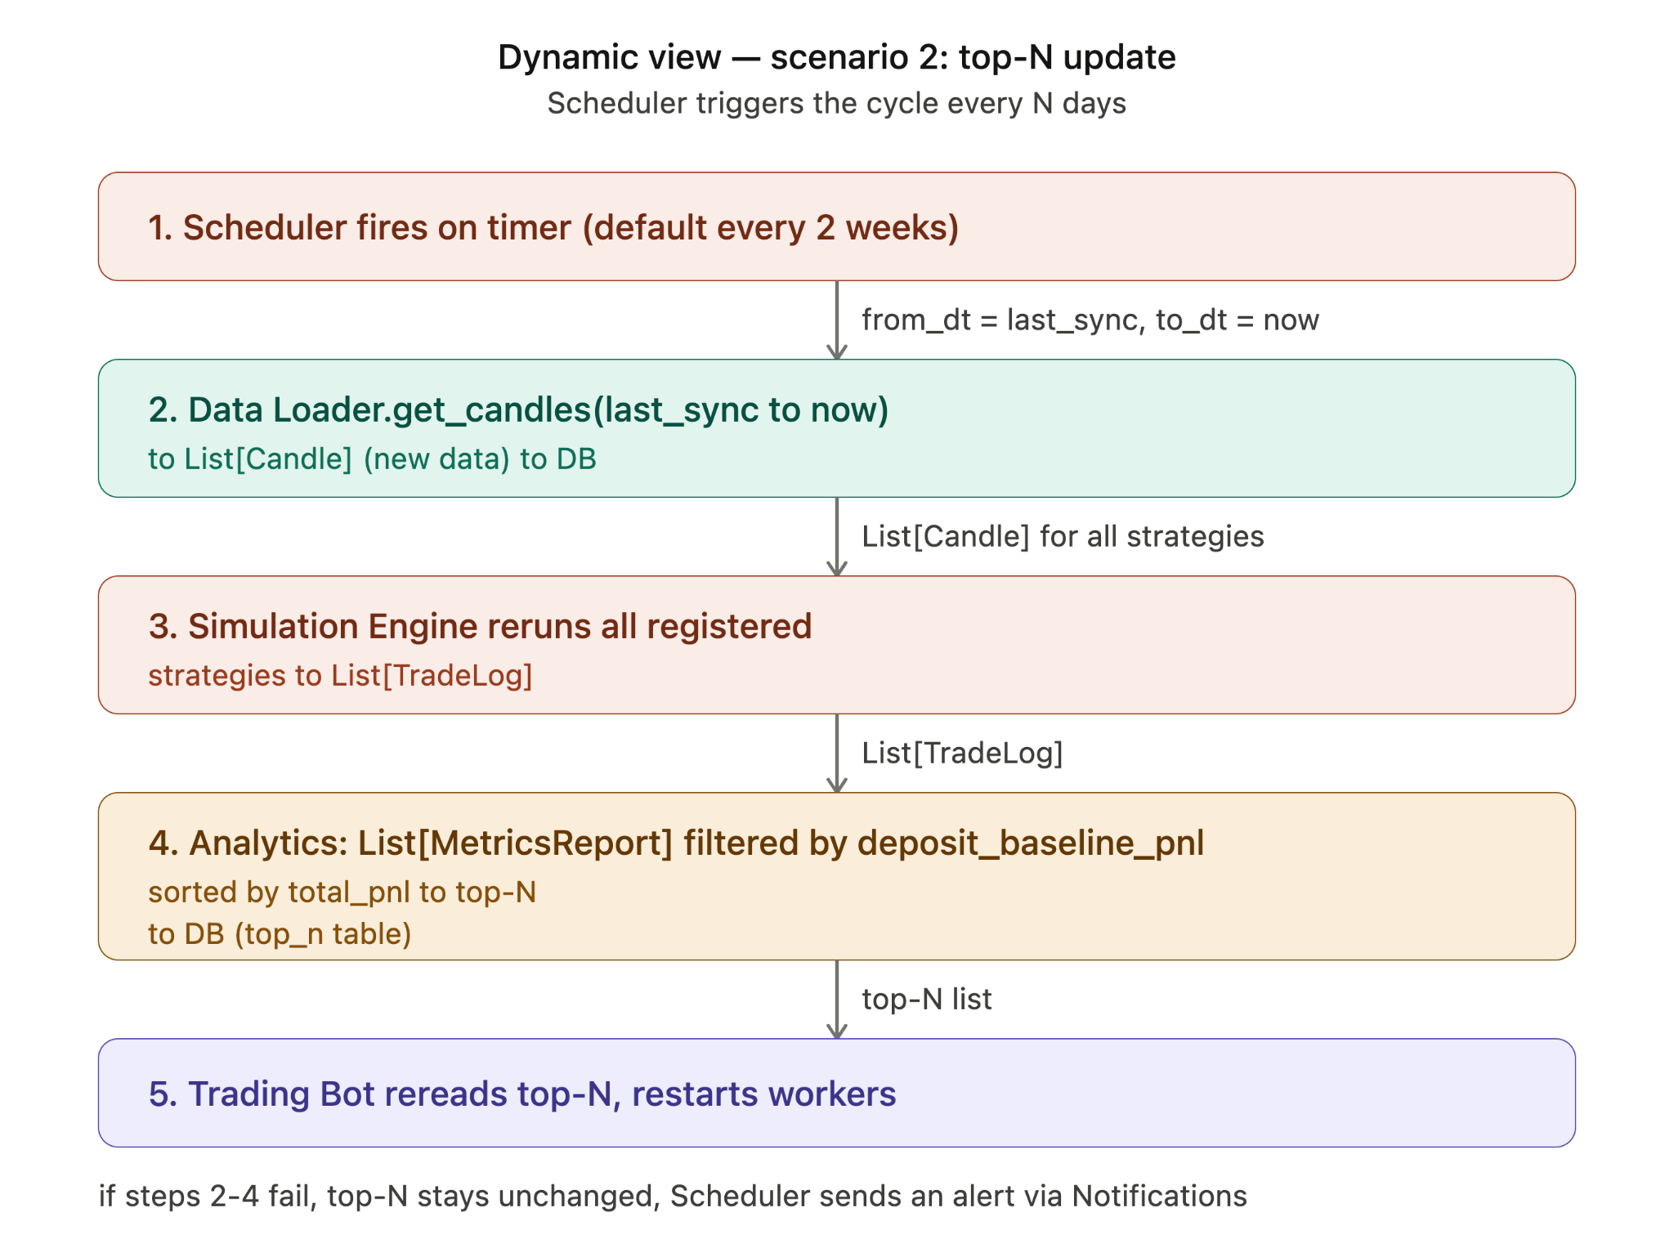
The dynamic view is split into two diagrams: the standalone backtest sequence (the MVP-1 scenario), and the backtest core wrapped in the scheduling loop (the MVP-2 scenario, which reuses the same core).

Diagram 1 - Backtest sequence (MVP-1)
This diagram shows the runtime sequence for a single backtest run, executed manually for one strategy on one instrument. This is the baseline sequence - everything else in the system is built around it.
- Broker Adapter.get_candles(instrument, from_dt, to_dt, timeframe) returns List[Candle].
- Data Loader validates, normalizes, and caches the candles to the database, returning clean List[Candle].
- Simulation Engine iterates over each Candle and calls strategy.on_candle(candle, portfolio), which returns a Signal (BUY / SELL / HOLD, with quantity and reason).
- Simulation Engine simulates order execution for each signal and accumulates all executed trades into a TradeLog (strategy_id, instrument, trades, final_portfolio_value).
- Analytics Module converts the TradeLog into a MetricsReport (total_pnl, sharpe_ratio, max_drawdown, win_rate, deposit_baseline_pnl) and writes it to the metrics and top_n tables.

Diagram 2 - Backtest core inside the scheduling loop (MVP-2)
This diagram shows how the exact same sequence from Diagram 1 (steps 1-5, shown here as the "Backtest core") is reused once an automated scheduling loop is added. The core itself is unchanged - only an orchestration layer is added around it.
- The Scheduler fires on a configurable timer (default: every 2 weeks). It tells Data Loader to fetch data from the last sync point to now, then runs the backtest core once per registered strategy using this fresh data.
(Steps 1-5 - identical to Diagram 1, executed once per strategy.)
- Analytics Module collects the resulting List[MetricsReport], filters out strategies whose total_pnl is below deposit_baseline_pnl, sorts the rest by total_pnl, and writes the result to the top_n table.
- Trading Bot rereads the top_n table and restarts its workers so that only the current best strategies are running.
Fault tolerance: if any step from 0 to 6 fails (e.g. the broker API is unreachable, or one strategy throws an exception during simulation), the current top_n list is left untouched and the Scheduler sends an alert via Notifications. Trading Bot continues operating on the last successful top_n list until the next successful recalculation.

Deployment view: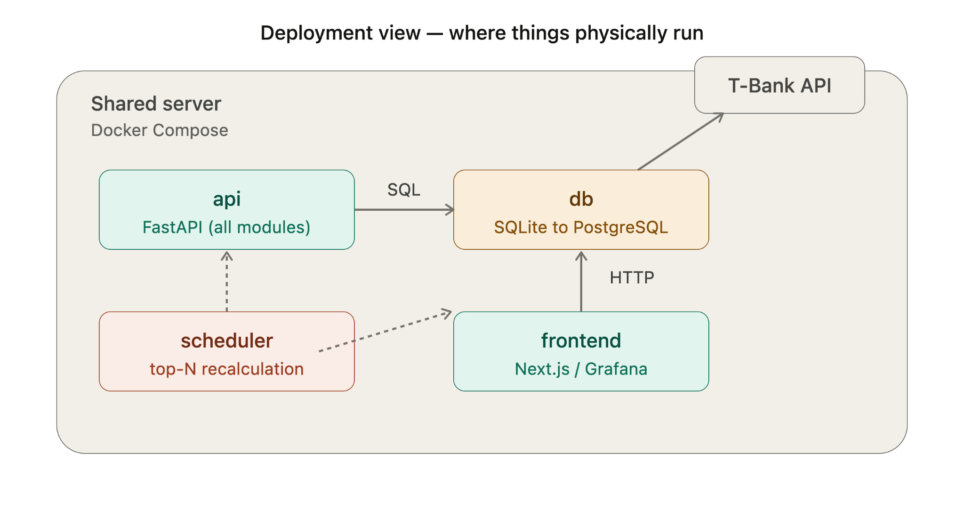
All components run as separate containers under a single Docker Compose stack on a shared server:
- api - the FastAPI application containing all core modules (Broker Adapter, Data Loader, Strategy Module, Simulation Engine, Analytics Module). This is the main entry point and the only container that talks to the database for read/write of application logic.
- db - the database container. Starts as SQLite for MVP-1 (a single file, no separate process), and is replaced by PostgreSQL once concurrent access or data volume requires it. The api, scheduler, and frontend containers all connect to it over SQL.
- scheduler - a separate container running the periodic recalculation job (APScheduler or cron). It connects to the db container directly to read strategy configs and write the updated top_n list, and triggers the backtest core logic exposed by api.
- frontend - either a Next.js application or, as a fallback, Grafana pointed directly at the db container. Communicates with api over HTTP for any data not directly queryable from the database, and/or reads from db directly for dashboards.
External dependency: the api container makes outbound calls to the T-Bank API (sandbox or production) through the Broker Adapter implementation. This is the only external network dependency in the system - everything else runs on the shared server.
Network summary:
- api ↔ db: SQL
- scheduler ↔ db: SQL (direct), plus calls into api for backtest execution
- frontend ↔ api: HTTP
- frontend ↔ db: SQL (optional, for Grafana fallback)
- api → T-Bank API: HTTPS
This separation means the database can be swapped (SQLite → PostgreSQL) or the frontend replaced (Next.js ↔ Grafana) without changing how any other container is deployed or how they connect to each other.

